Predicting Rent prices in Toronto Canada

Salim Al-harthi

16 July 2021

1. **Introduction** 
   1. **Background**

People are renting houses and apartments to live in for years or months. It is important for people who rent a house or an apartment to get a fair price for the place they are renting.

By utilizing the information of the rent of different properties we can build a model that will accurately predict a fair price for rent according to different factors such as number of bathroom and bedrooms, number of different venues nearby and more.

* 1. **problem**

People who live in a city will have an idea on what a fair rent should be. However, for the people who are new to the city, they must research and find the fair price for rent, or they might end up paying an overpriced rent.

* 1. **Interest**

As mentioned, in 1.2 people who are moving to a new city will benefit from this solution since it will save them all the research time.

1. **Data acquisition and cleaning**
   1. **Data sources**

Most of the data such as price, latitude, longitude, number of bedroom, and number of bathroom will be coming from Kaggel dataset [here](https://www.kaggle.com/rajacsp/toronto-apartment-price) and the data related to the venues nearby the property will be coming from [foursquare.com](https://foursquare.com/) API.

* 1. **Data cleaning**

The data were downloaded from Kaggel contained the following columns:

|  |  |  |  |
| --- | --- | --- | --- |
| **Column name** | **Description** | **Data type** | **Example** |
| Bedroom | How many bedrooms available | Integer | 2 |
| Bathroom | How many bathrooms available | float | 2.0 |
| Den | Whether den is available or not | Boolean | 1 |
| Address | Location | string | 361 Front St W, Toronto, ON M5V 3R5, Canada |
| Lat | Latitude | float | |  | | --- | | 43.643051 | |
| Long | Longitude | float | -79.391643 |
| Price | Apartment Rental price per month in CAD | String | 2450.0$ |

Table Kaggel columns

Cleaning the data consist of removing ($) from **Price** column then convert it to Float.

|  |  |  |  |
| --- | --- | --- | --- |
| **Datapoint** | **Description** | **Data type** | **Example** |
| Lat | Latitude | float | |  | | --- | | 43.643051 | |
| Long | Longitude | float | -79.391643 |
| Venue name | Venue name | String | Rathburn Plaz |
| categories | Venue categories | String | Salon / Barbershop |
| Categories icon | Icon url | URL | <https://ss3.4sqi.net/img/categories_v2/shops/salon_barber_> |

The data from the API returned as Json object. And consist of several data. However, the important data points are:

Table important data from API

For cleaning the API data, the **Categories icon** was reduced to main category for example.

The following **Categories icon:**

<https://ss3.4sqi.net/img/categories_v2/shops/salon_barber_>

‘https:’, ‘’, ‘ss3.4sqi.net’, ‘img’,’categories_v2’,’shops’,’salon_barber_’

|  |  |
| --- | --- |
| **Category** | **Description** |
| food | Restaurants, coffee shops etc. |
| Shops | Supermarkets etc. |
| Building | Library office building and others |
| Art entertainment | Museums |
| Travel | Bus stops train and airports |
| Nightlife | Bars and clubs |
| Parks outdoors | Parks |
| Education | Schools and universities |

it reduced to **shops.** The process output was 8 main categories:

Table 8 main categories

**2.3 Feature selection**

After data cleaning it is the time to select the features. For the features coming from Kaggel the dropped features were as following:

|  |  |
| --- | --- |
| **Feature** | **Reason to drop** |
| Address | Latitude and Longitude provide the location of the property and Address are unique to each property. |

Table Dropped features

The remaining features:

|  |  |  |
| --- | --- | --- |
| **Column name** | **Description** | **Data type** |
| Bedroom | How many bedrooms available | Integer |
| Bathroom | How many bathrooms available | float |
| Den | Whether den is available or not | Boolean |
| Lat | Latitude | float |
| Long | Longitude | float |
| Price | Apartment Rental price per month in CAD | String |

Table Remaining features from Kaggel

For the features coming from the API. The features remained were the 8 main categories and their latitude and longitude. The features remained as the following:

|  |  |  |
| --- | --- | --- |
| **Datapoint** | **Description** | **Data type** |
| Lat | Latitude | float |
| Long | Longitude | float |
| categories | 8 main categories | String |

Table Remaining features from API

Next is margining all features into one table. And the result table has the following features:

|  |  |  |  |
| --- | --- | --- | --- |
| **Column name** | **Description** | **Data type** | **Example** |
| Bedroom | How many bedrooms available | Integer | 2 |
| Bathroom | How many bathrooms available | float | 2.0 |
| Den | Whether den is available or not | Boolean | 1 |
| Lat | Latitude | float | |  | | --- | | 43.643051 | |
| Long | Longitude | float | -79.391643 |
| Price | Apartment Rental price per month in CAD | Float | 2450.0 |
| food | Count of occurrence of the category near by the property | Integer | 1 |
| Shops | Count of occurrence of the category near by the property | Integer | 2 |
| Building | Count of occurrence of the category near by the property | Integer | 9 |
| Art entertainment | Count of occurrence of the category near by the property | Integer | 1 |
| Travel | Count of occurrence of the category near by the property | Integer | 2 |
| Nightlife | Count of occurrence of the category near by the property | Integer | 0 |
| Parks outdoors | Count of occurrence of the category near by the property | Integer | 1 |
| Education | Count of occurrence of the category near by the property | Integer | 0 |

Table All features

1. **Exploratory Data Analysis**
   1. **Relationship between features (Bathrooms, Bedrooms, Den, Latitude, and Longitude) and target (rent)**

As shown in (Figure 1.1) the increase of number of bathrooms and bedrooms cause the minimum and maximum amount rent increases.

The properties with den has a higher minimum rent in compare to the properties without den as shown in (Figure 1).

As shown in (Figure 1) most of the properties are closer to (44, -80) latitude, and longitude.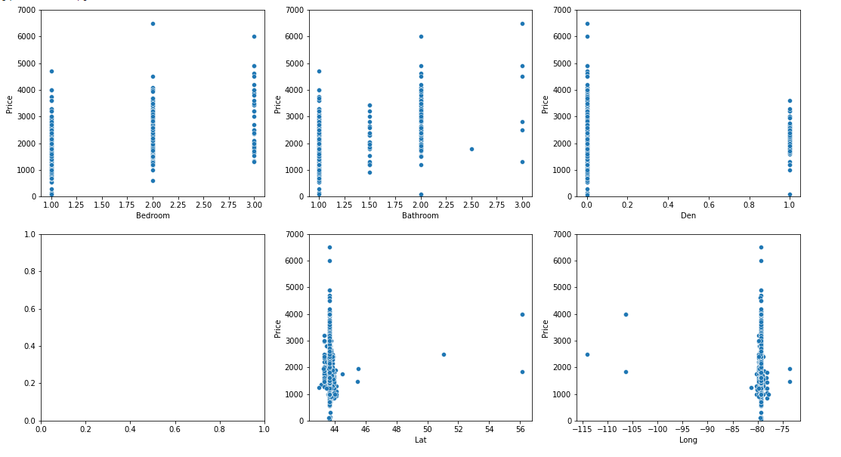

Figure 1 Relationship between features (Bathrooms, Bedrooms, Den, Latitude, and Longitude) and Price

Figure 1.1 box plot features (Bathrooms, Bedrooms, and Den) and Price

* 1. **Relationship between features (Latitude, and Longitude) and target (rent)**

As shown in (Figure 2) most of the property from latitude, and longitude (43.65,-79.4) the lower the maximum rent price is.

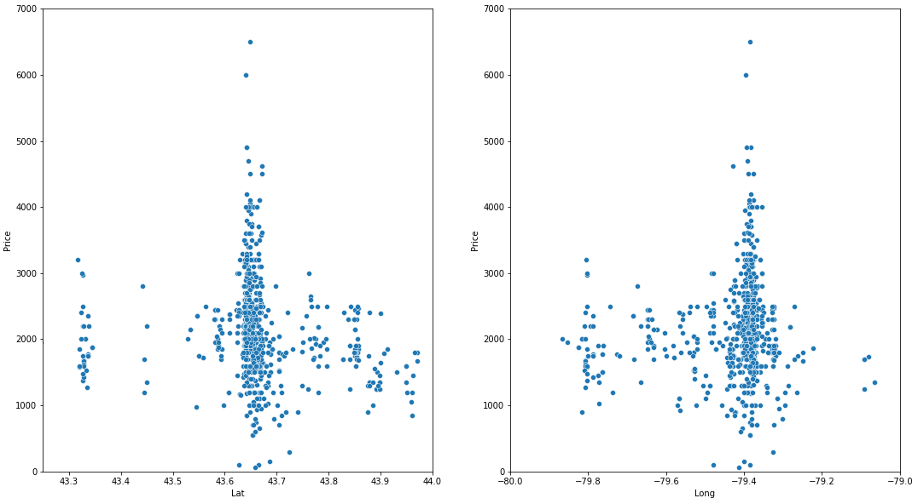

Figure 2 Relationship between features (Latitude, and Longitude) and Price

* 1. **Relationship between 8 main categories and target (rent)**

As shown in (Figure 3) the in crease in number of travel, parks_outdoors, and arts_entertainment, cause the minimum and maximum amount rent increases.

As shown in (figure 3.1) the change in number of occurrences changes the range of the price.

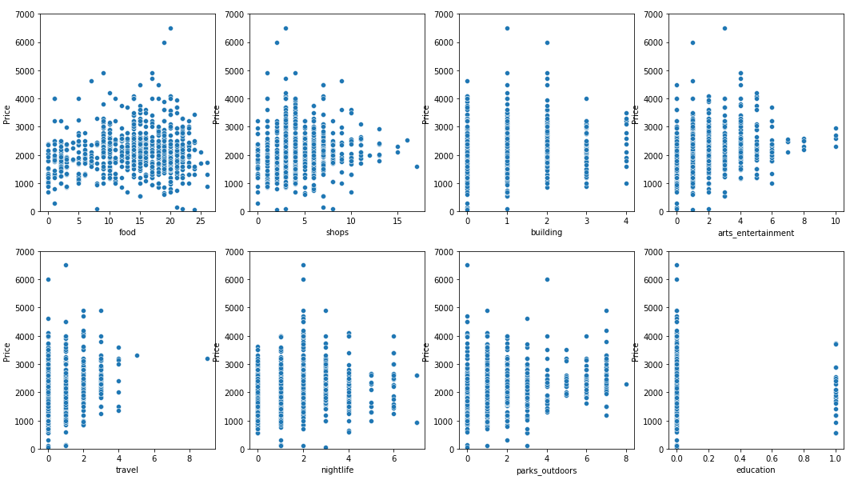

Figure 3 Relationship between 8 main categories and Price

Figure 4.1 box plot Relationship between features (Latitude, and Longitude) and Price

* 1. **Distribution of properties**

As shown in (Figure 4) most of the properties are closer to the middle of Toronto with some on the edges of the city.

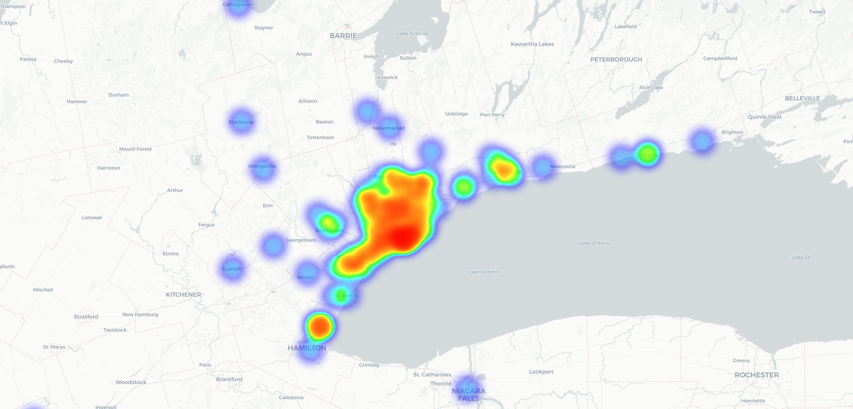

Figure 4 Distribution of properties

1. **Predictive Modeling**

To Predict the rent of a property a regression model is the best fit. In this case 3 regression models have been used Gradient Boosting Regressor, Random Forest Regressor, and KNN Regressor

* 1. **Solution to the problems**

The problem was to predict the rent for different properties. Therefore, the model must be able to predict a value that close to the real value hence using R2.

* 1. **Performances of different models**

The models that have been used to predict the rent value had performed closely. The average in the accuracy between the models was 84% with KNN Regressor on top as shown in the table8

|  |  |  |  |
| --- | --- | --- | --- |
| Model | Gradient Boosting Regressor | , Random Forest Regressor | KNN Regressor |
| Accuracy (R2) | 88.3% | 77% | 84.0% |

Table Models accuracy

In figure5 show the predicted value and real value for each property. Figure 5 confirms that the models are predicting good values not randomly selecting a value

Figure Prediction vs real price

1. **Conclusions**

In conclusion in this study, I attempted to predict the rent of some properties in Toronto. I have performed analyses on the features from Kaggel dataset as well as [foursquare.com](https://foursquare.com/) API. I used three different models Gradient Boosting Regressor, Random Forest Regressor, and KNN Regressor to predict the rent of the properties and found that KNN Regressor performed the best in term of accuracy (R2).

1. **Future directions**

For the future of thisproject, I’m planning to build a simple website that will take the latitude, longitude, number of bathroom bedroom and if there is a den and output a predicted rent price.

In addition, this project must be updated regularly because rent prices are affected by economical changes.